ECS - ELASTIC CONTAINER SERVICE TASKS

- Setup a highly available ecs cluster with load balancer and dynamic port mapping.
NOTE:
Your cluster should maintain atleast 6 tasks at any point of time and should be highly availble across multiple AZ's.
Use the below image from deployment:
sabair0509/hiring-app:works

Highly Available ECS Cluster with ALB & Dynamic Port Mapping
Objective
Deploy ECS (EC2 launch type) with:
- Application Load Balancer
- Dynamic Port Mapping
- Minimum 6 running tasks
- Multi-AZ high availability
- Image: sabair0509/hiring-app:works
Step 1: Create IAM Roles
ECS Instance Role
- IAM → Create Role → AWS Service → EC2
- Attach: AmazonEC2ContainerServiceforEC2Role
- Name: ecsInstanceRole
ECS Task Execution Role
- IAM → Create Role → AWS Service → ECS Task
- Attach: AmazonECSTaskExecutionRolePolicy
- Name: ecs-task-execution
Step 2: Create ECS Cluster (EC2)
- ECS → Create Cluster → EC2 Instances
- Cluster name: hiring-app-cluster
- Instance type: t3.large
- Min: 2 instances
- Max: 6
- Instance role: ecsInstanceRole
Ensure instances launch in multiple AZs.
Step 3: Create Task Definition
- ECS → Task Definitions → Create
- Family: hiring-app-task-definition
- Launch type: EC2
- Network mode: bridge
- CPU: 0.5 vCPU
- Memory: 1GB
Container
- Name: hiring-app
- Image: sabair0509/hiring-app:works
- Container port: 8080
- Host port: 0 (Dynamic port mapping)
Step 4: Create Target Group
- EC2 → Target Groups → Create
- Type: Instances
- Protocol: HTTP
- Port: 80
- Health check path: /
- Success codes: 200-499
Step 5: Create Application Load Balancer
- EC2 → Load Balancers → Create ALB
- Name: hiring-alb
- Scheme: Internet-facing
- Select 2 subnets (Multi-AZ)
- Listener: HTTP 80
- Forward to target group
Step 6: Create ECS Service
- Cluster → Create Service
- Task definition: Latest
- Service name: hiring-app-service
- Launch type: EC2
- Desired tasks: 6
- Deployment type: Rolling update
Load Balancing
- Use existing ALB
- Select target group
- Container: hiring-app
- Port: 8080
Step 7: Enable Auto Scaling
- Minimum tasks: 6
- Maximum tasks: 12
- Policy: Target Tracking
- Metric: ECSServiceAverageCPUUtilization
- Target: 70%
Result
- 6 tasks always running
- Tasks distributed across multiple AZs
- ALB distributes traffic
- Dynamic port mapping enabled
- Highly available architecture achieved
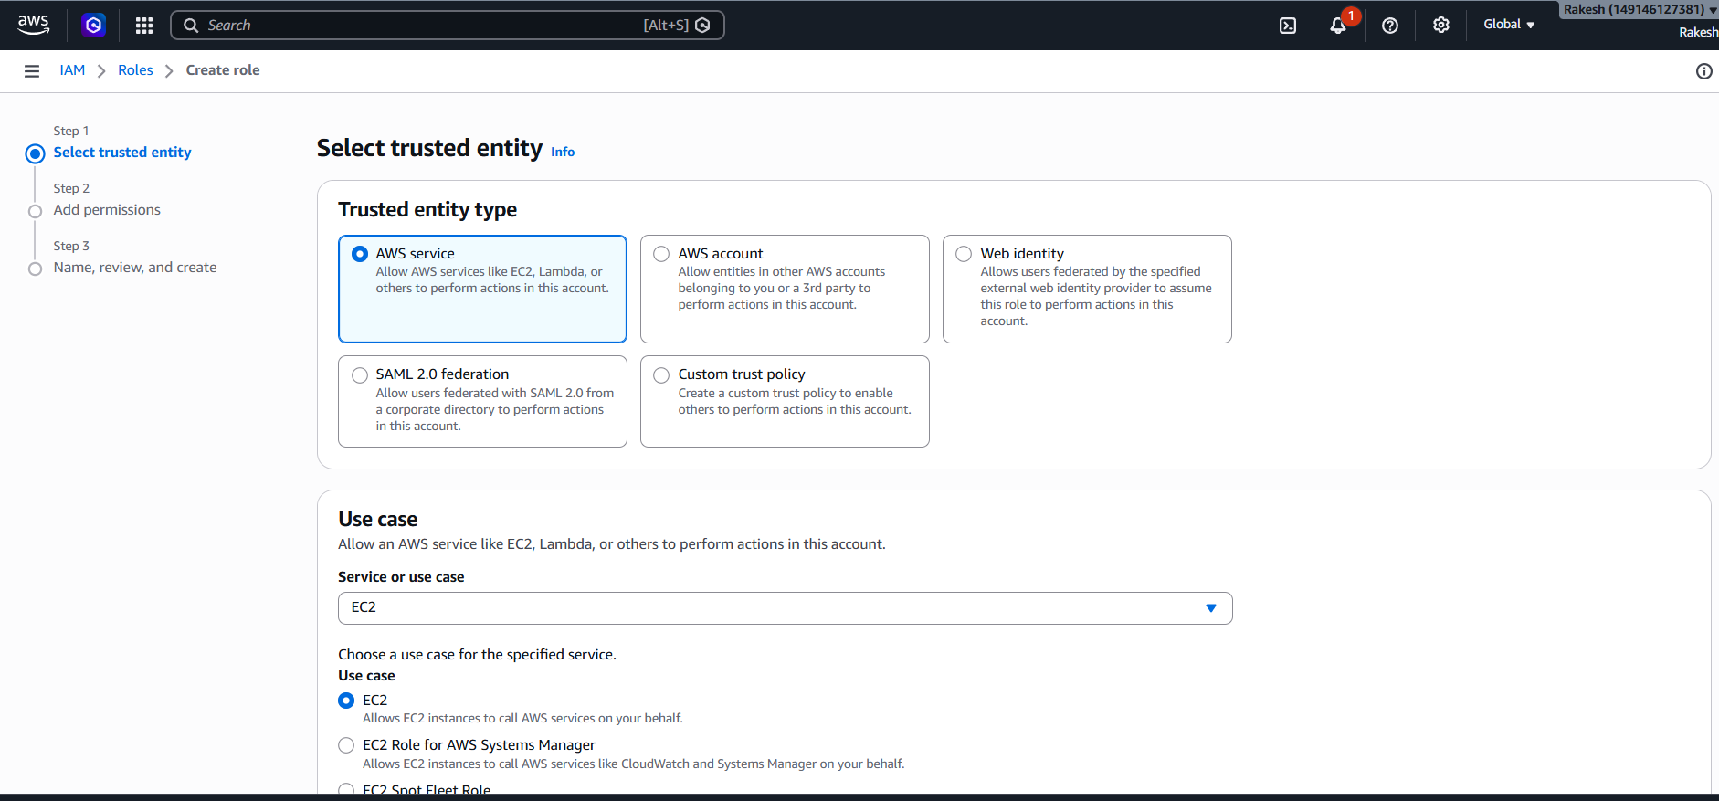
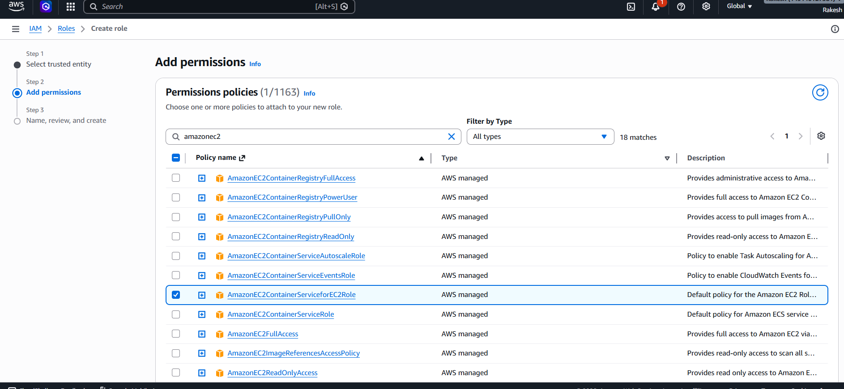
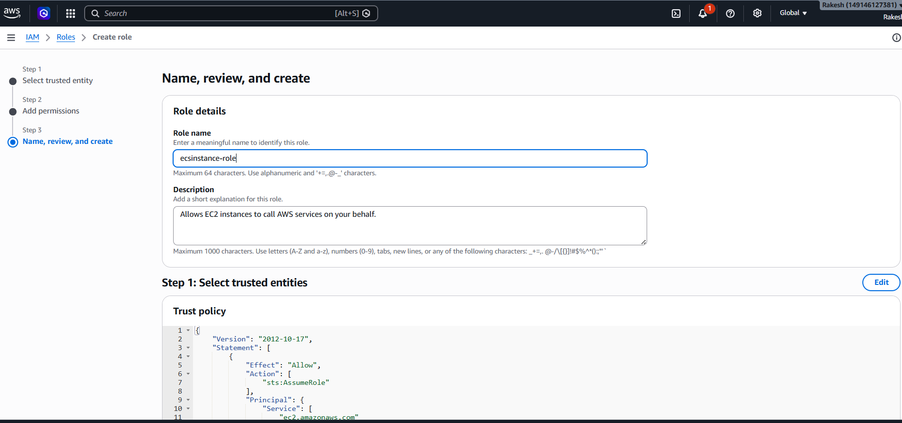
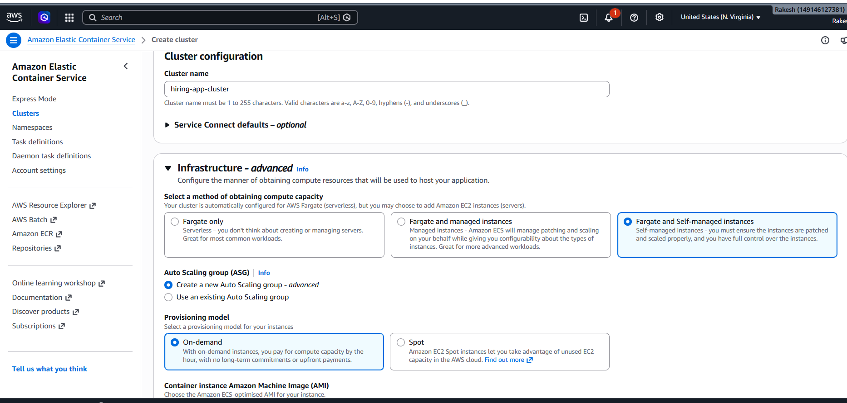

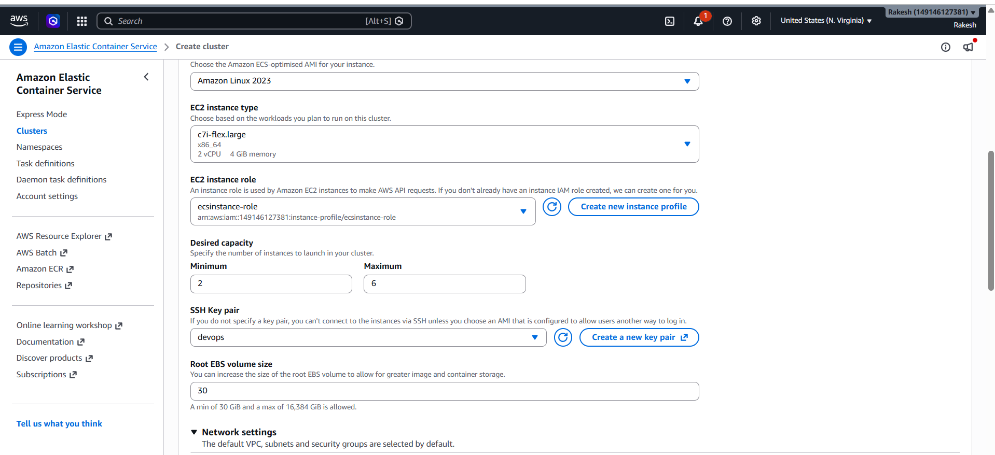
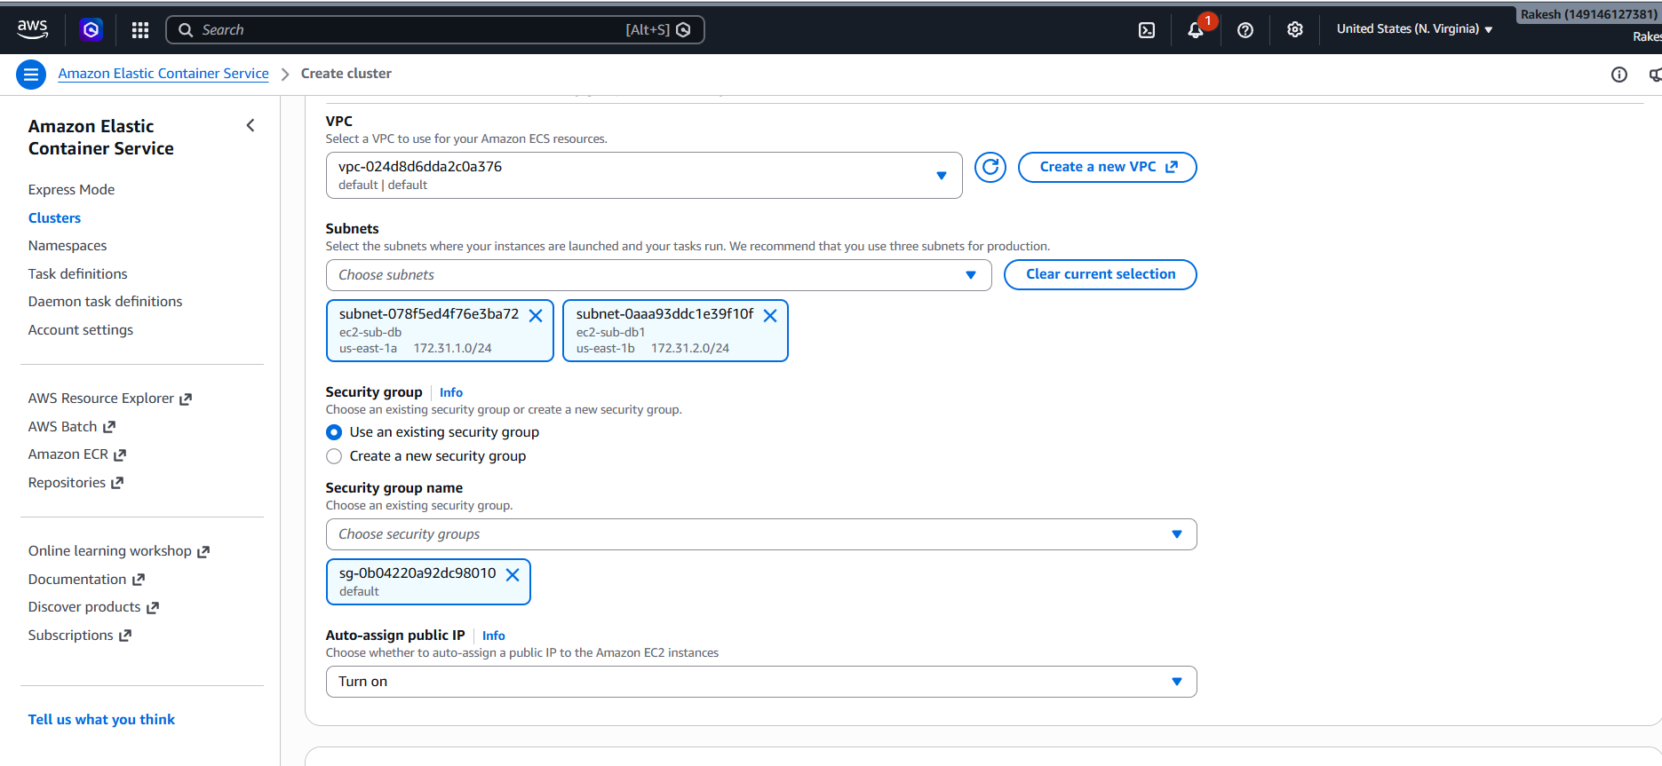

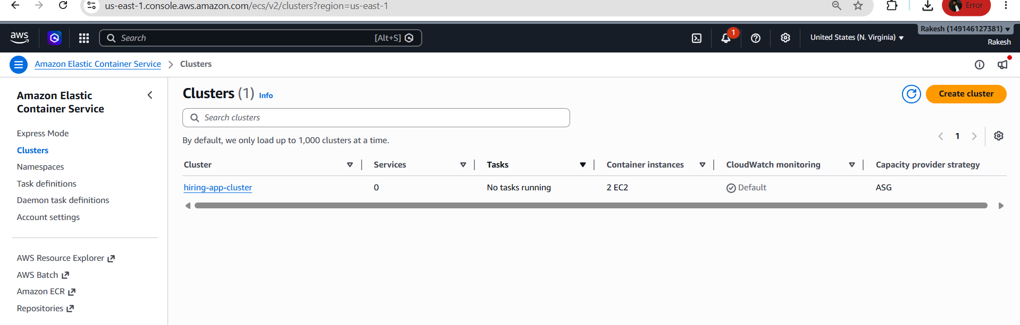
Created cluster
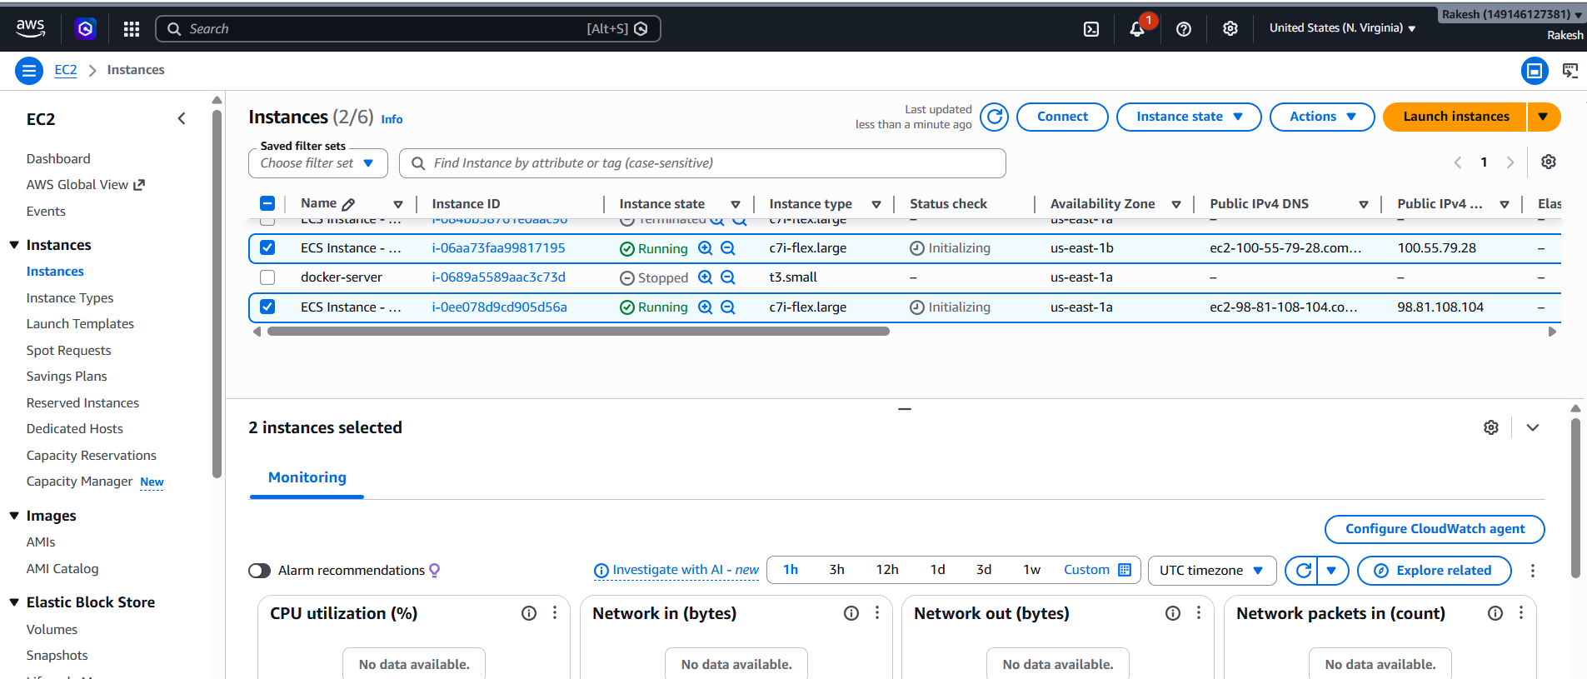
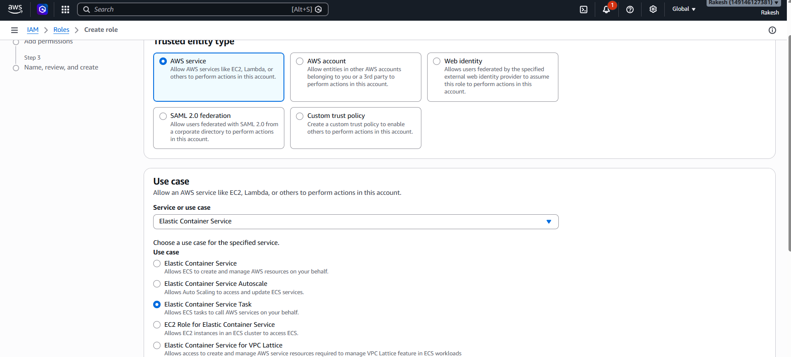
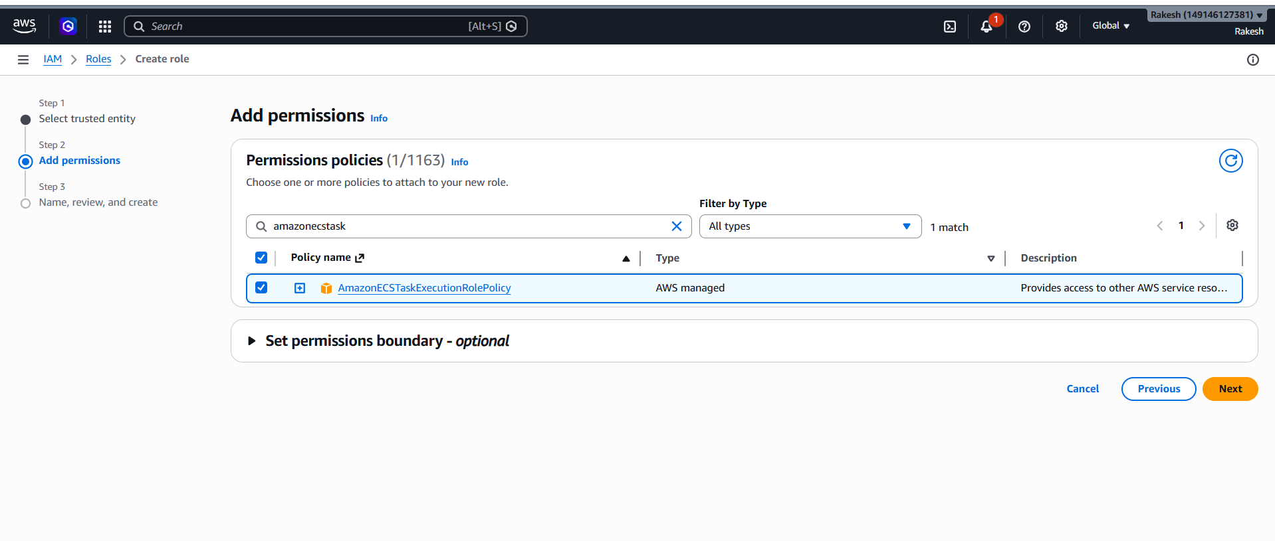
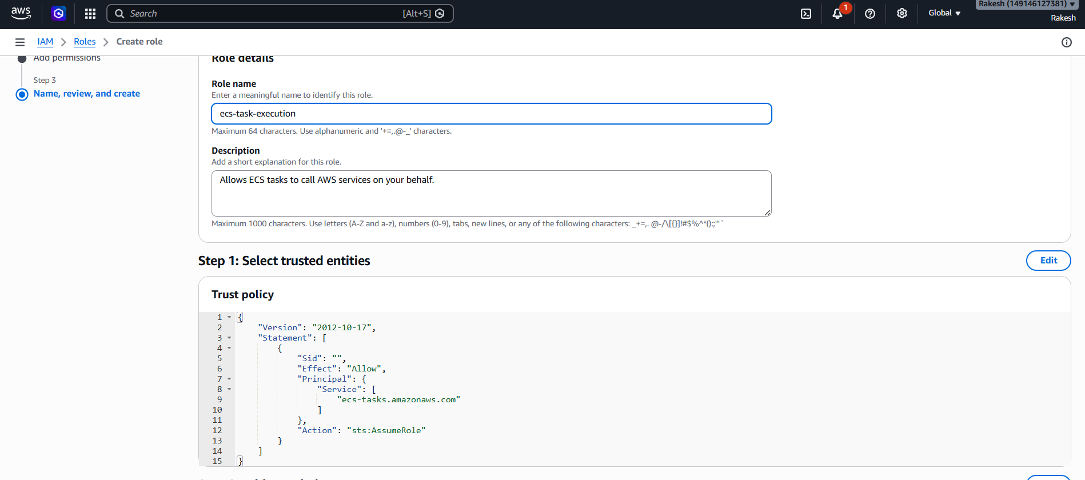

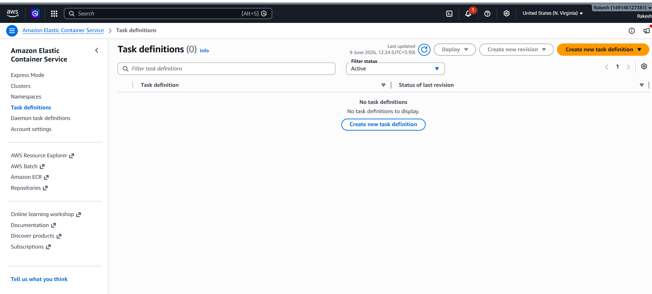

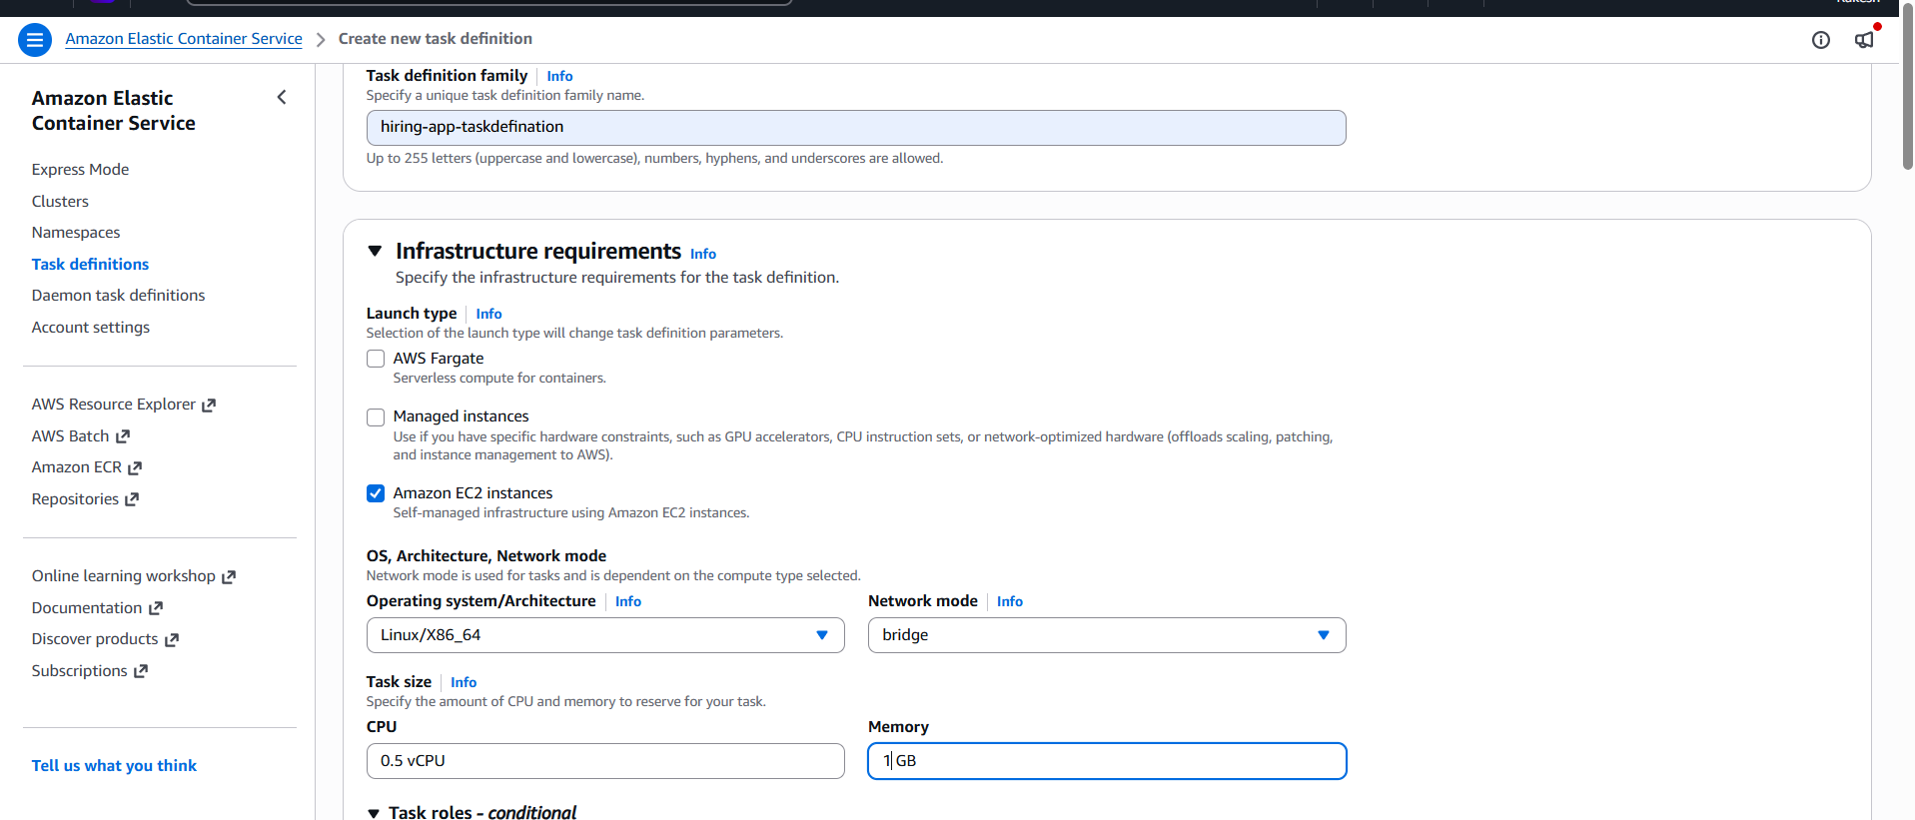
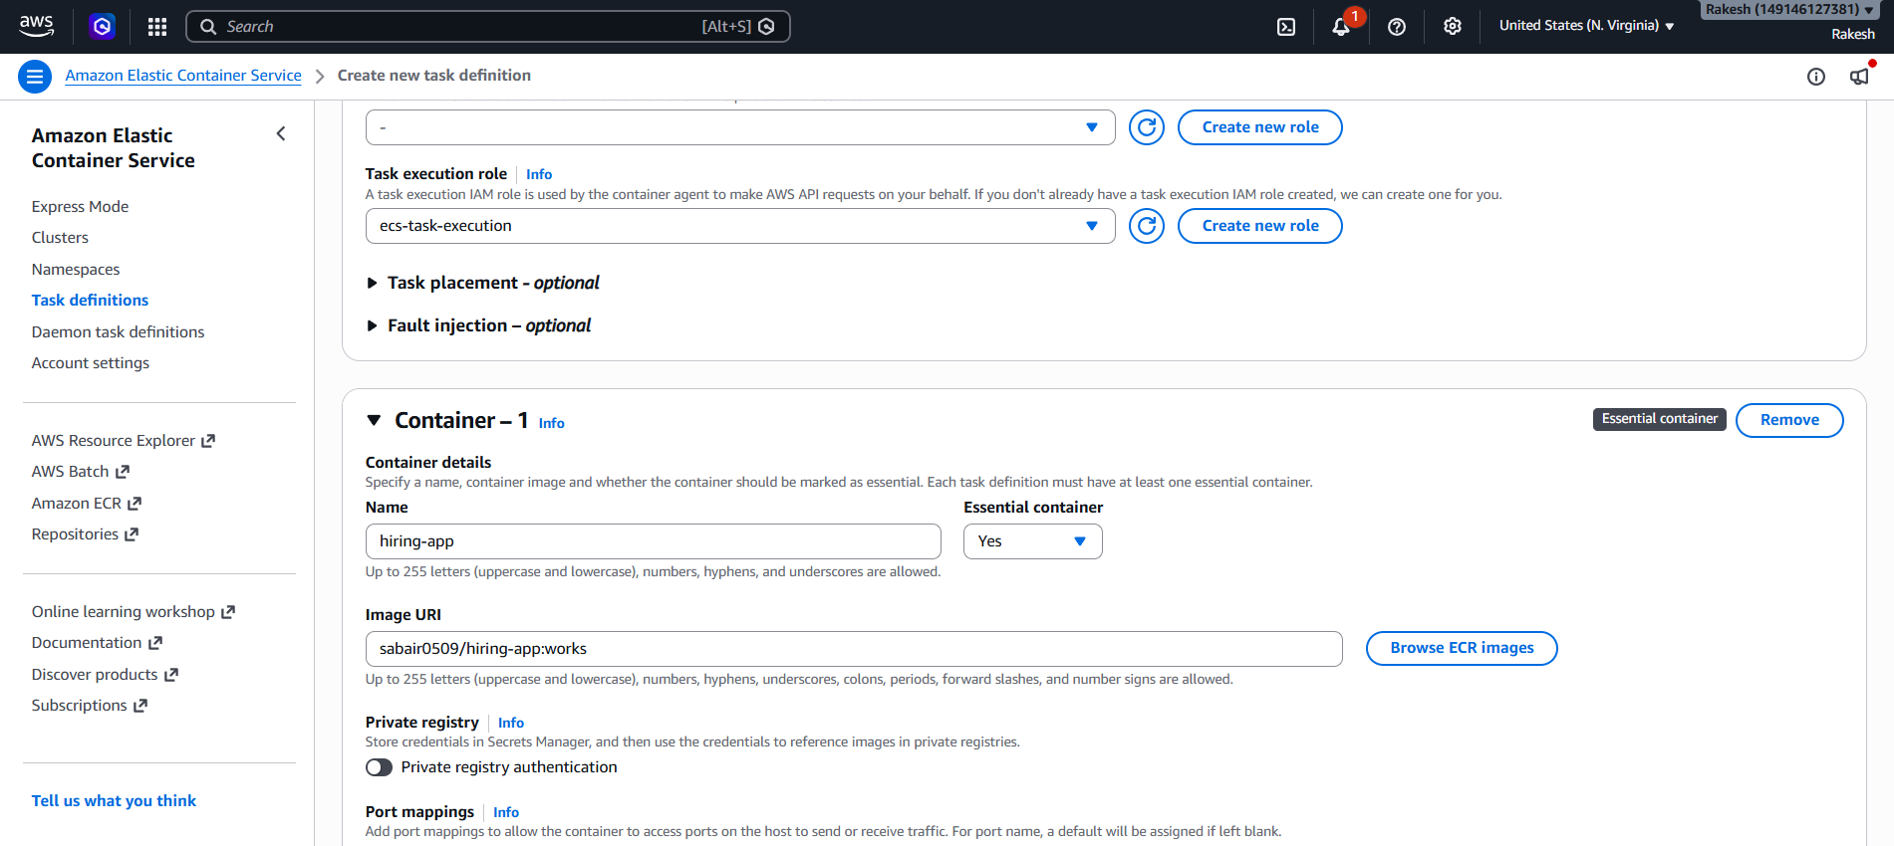

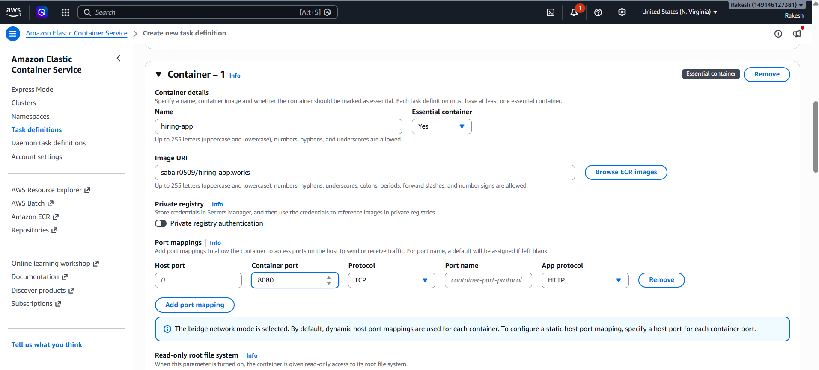
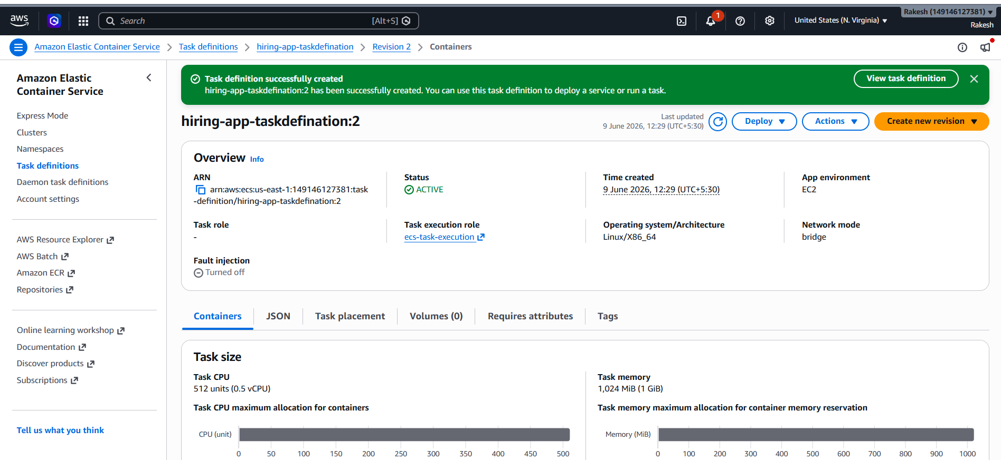

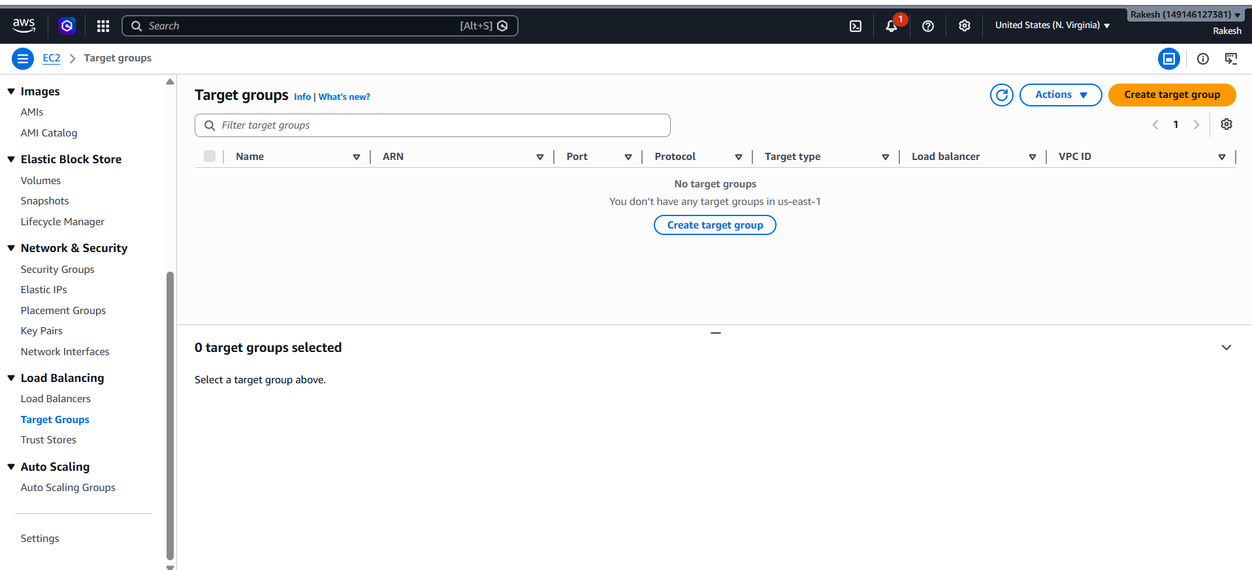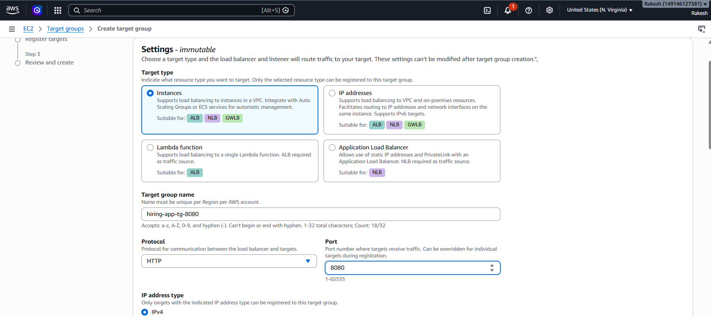

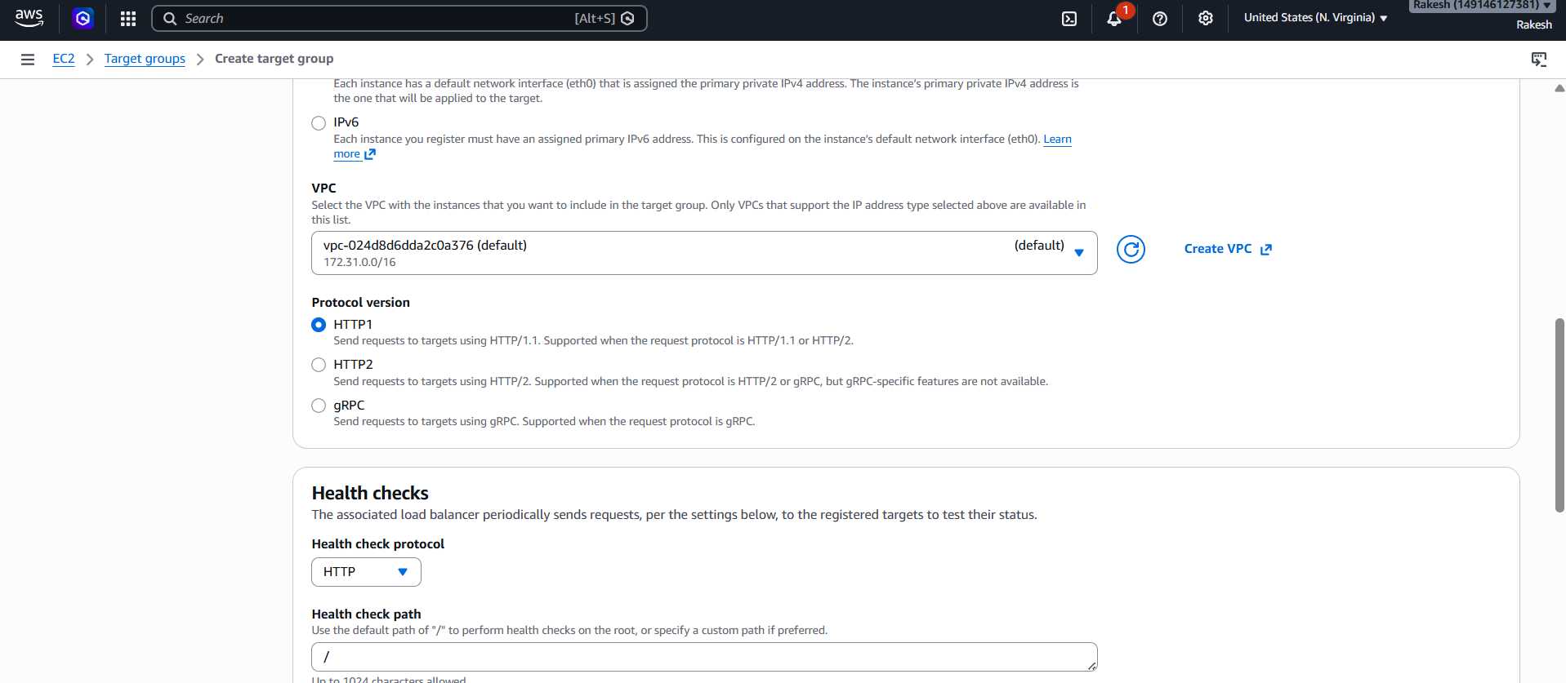

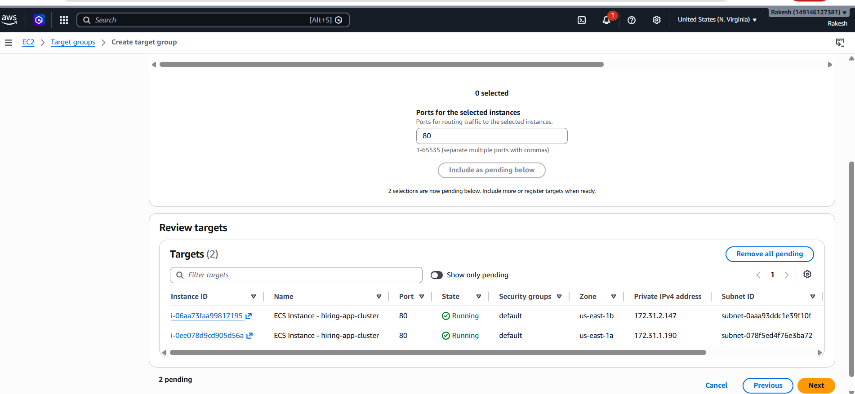

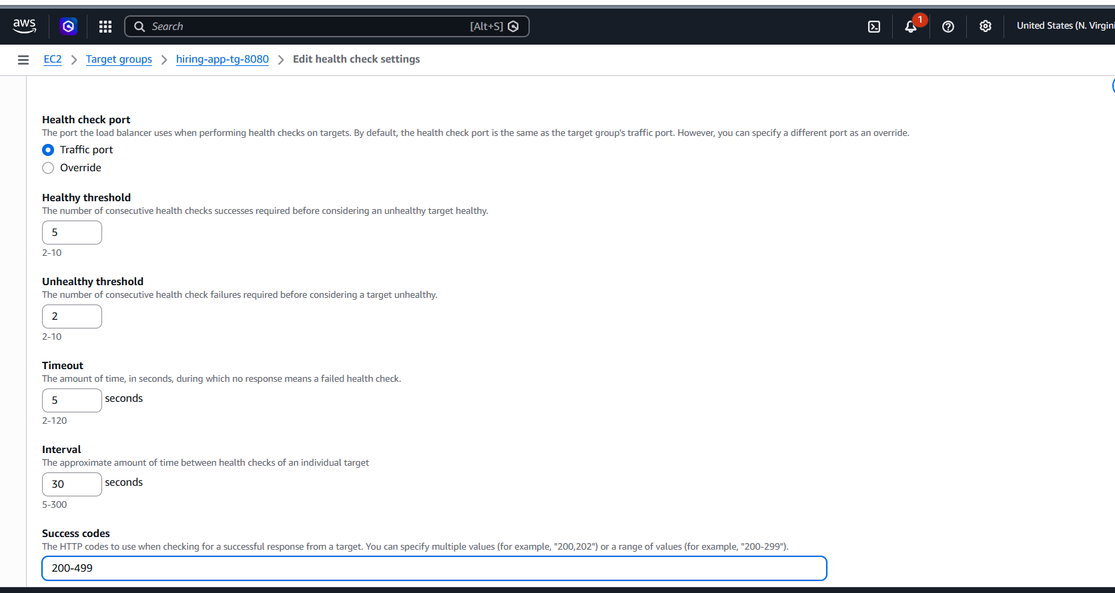
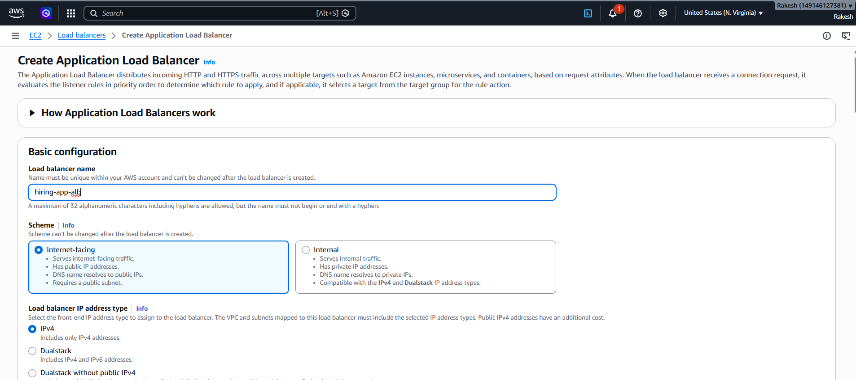

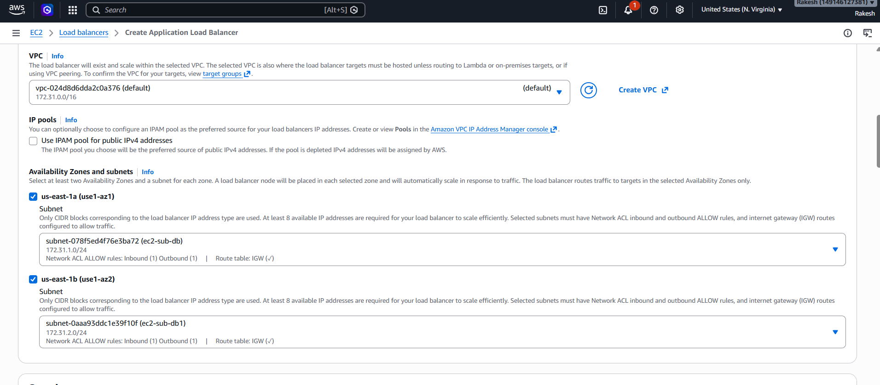

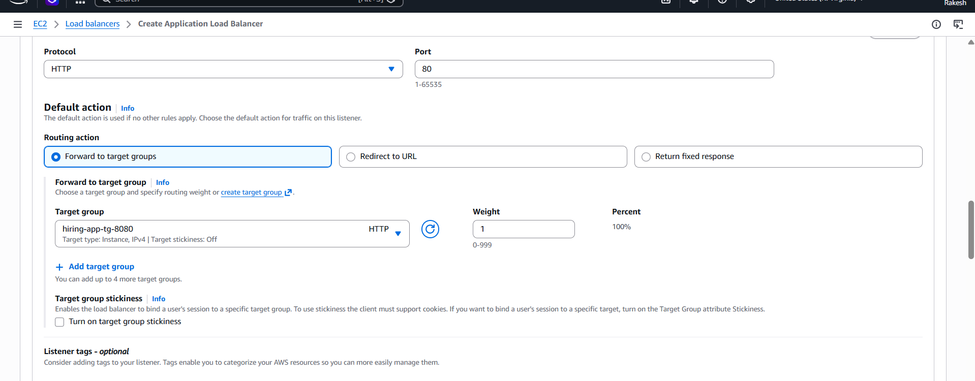
Created application load balancer
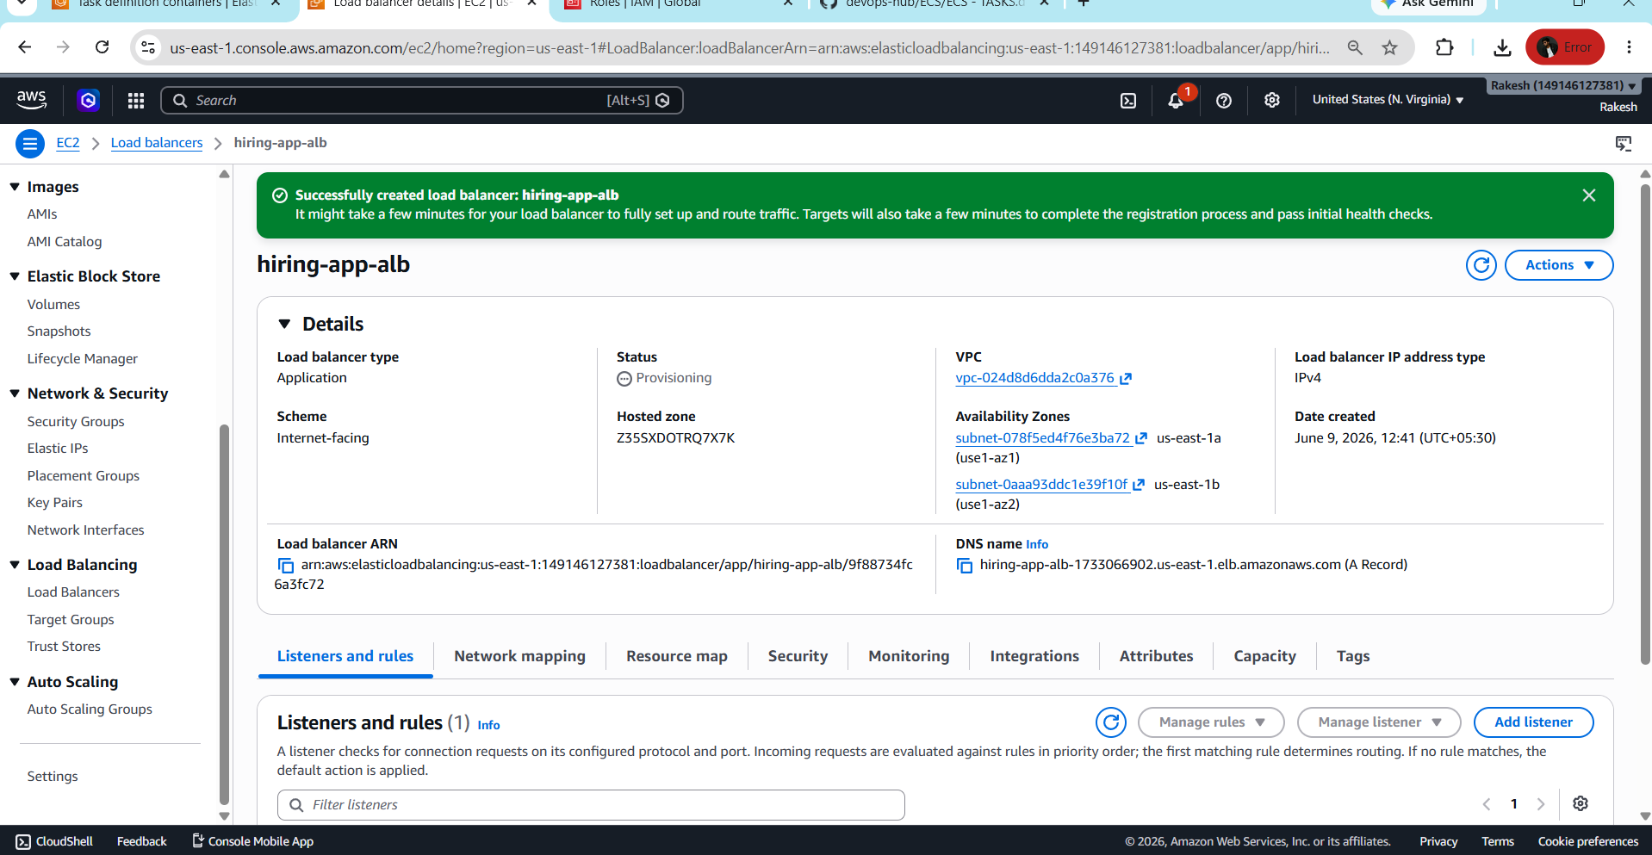
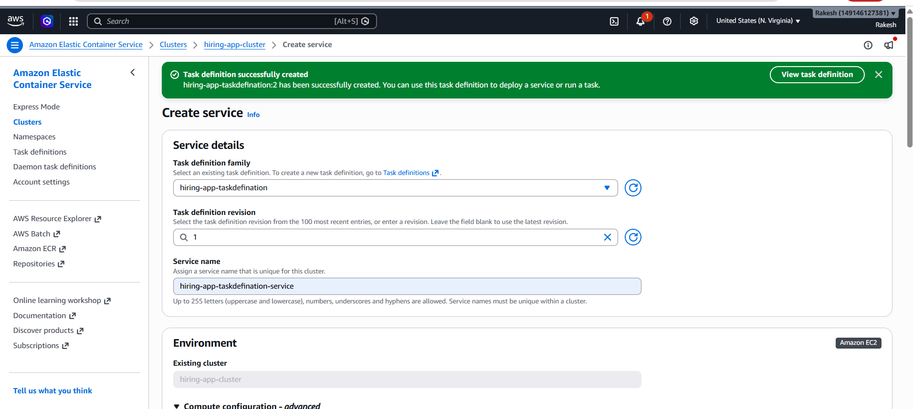
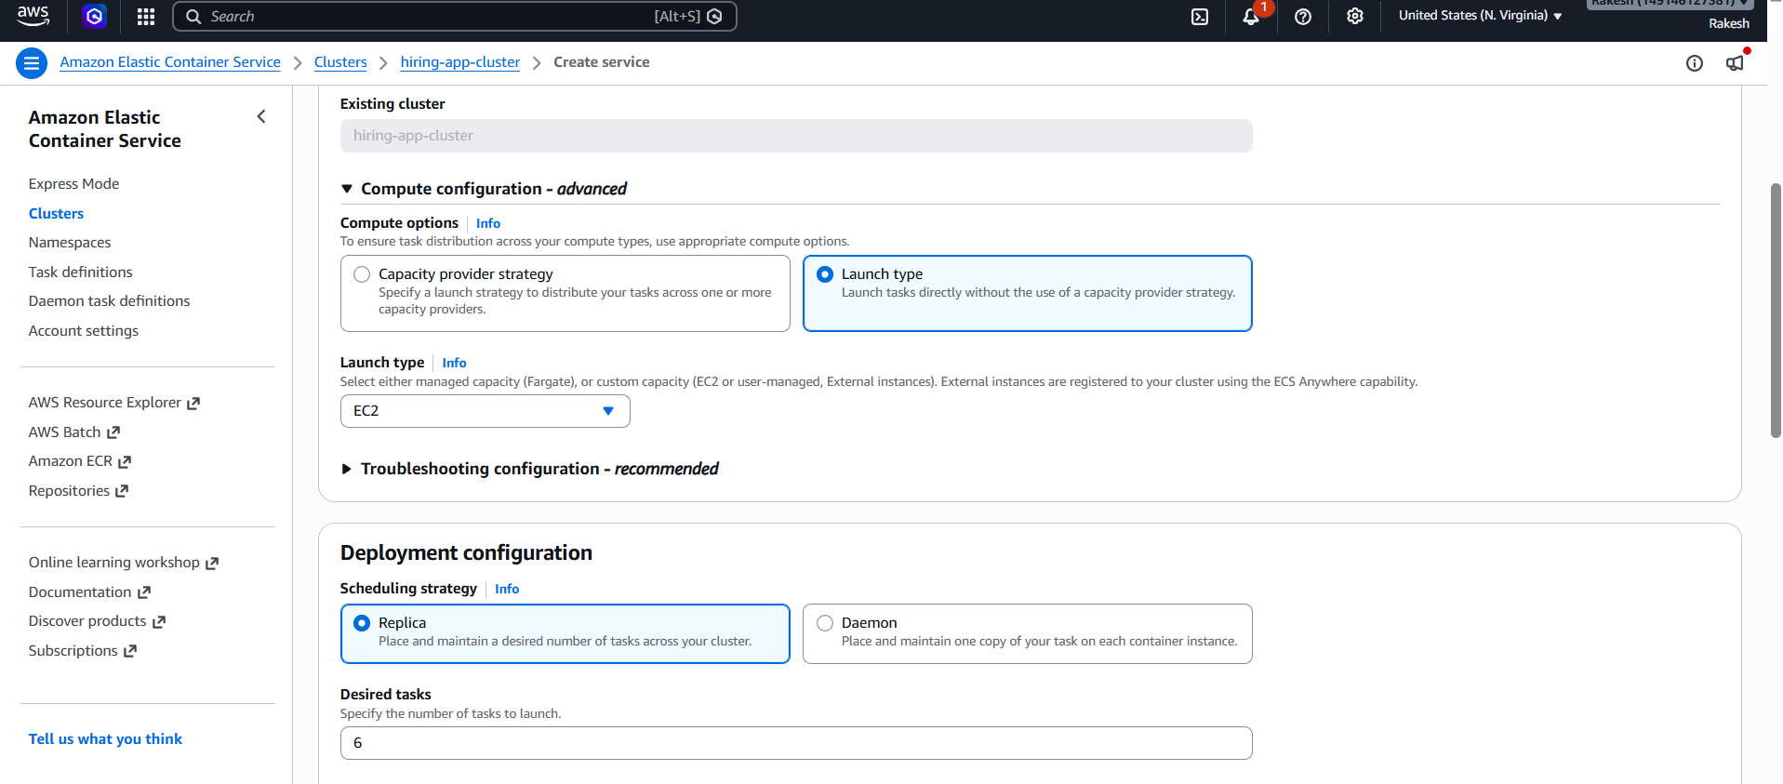
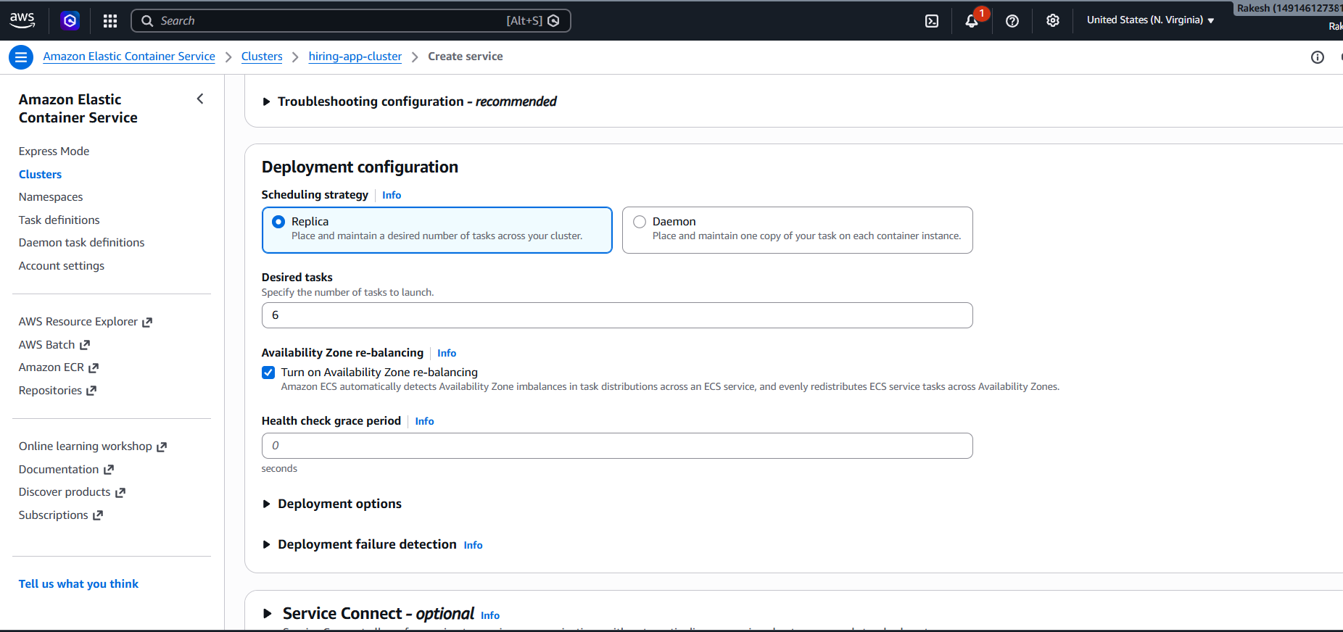
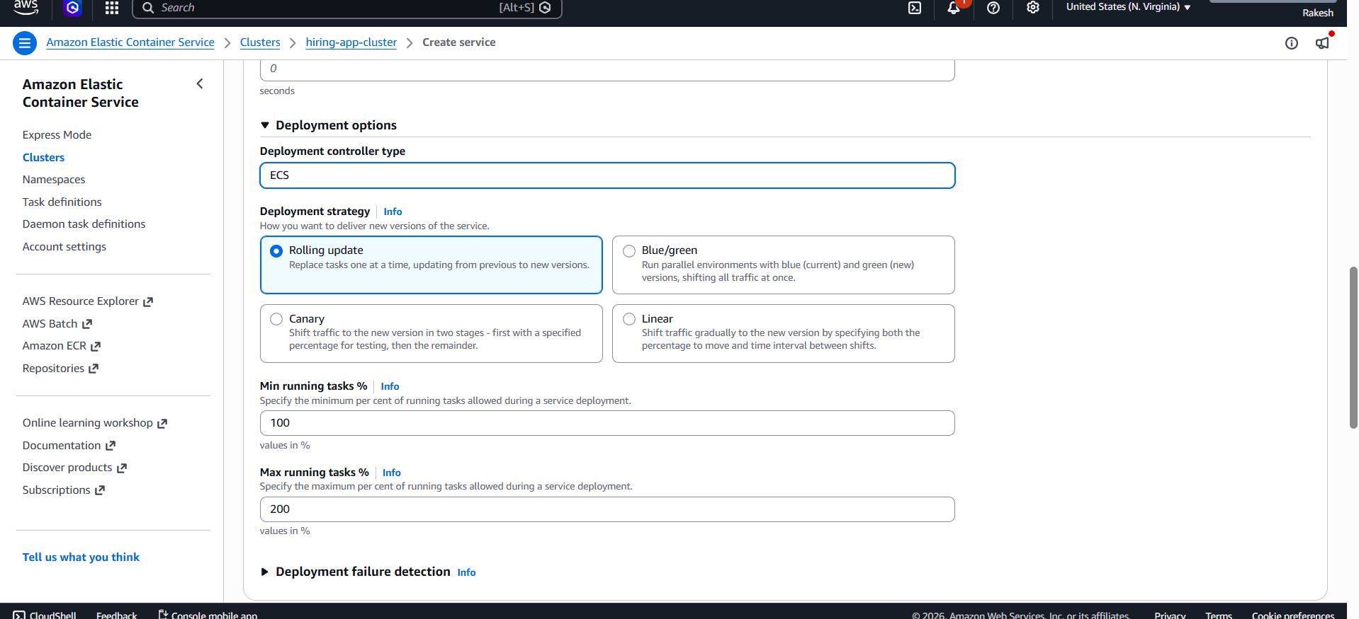

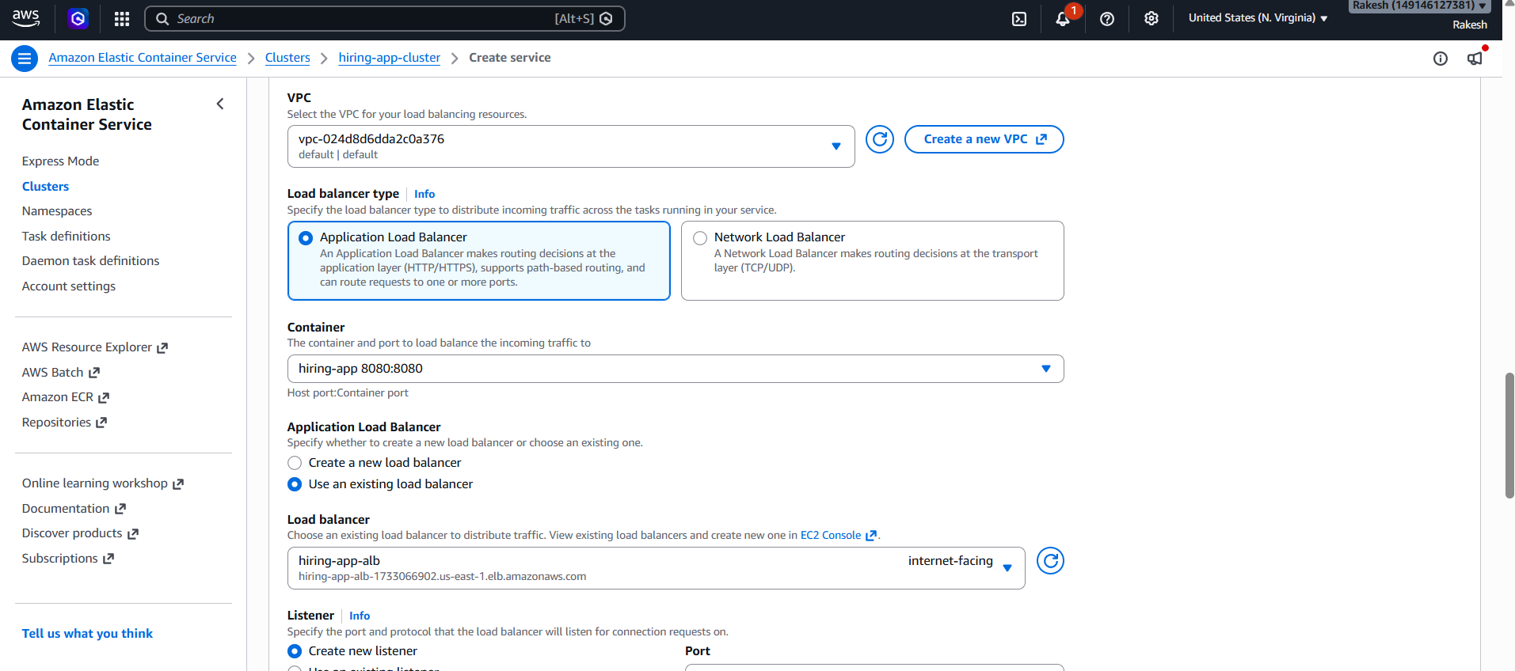

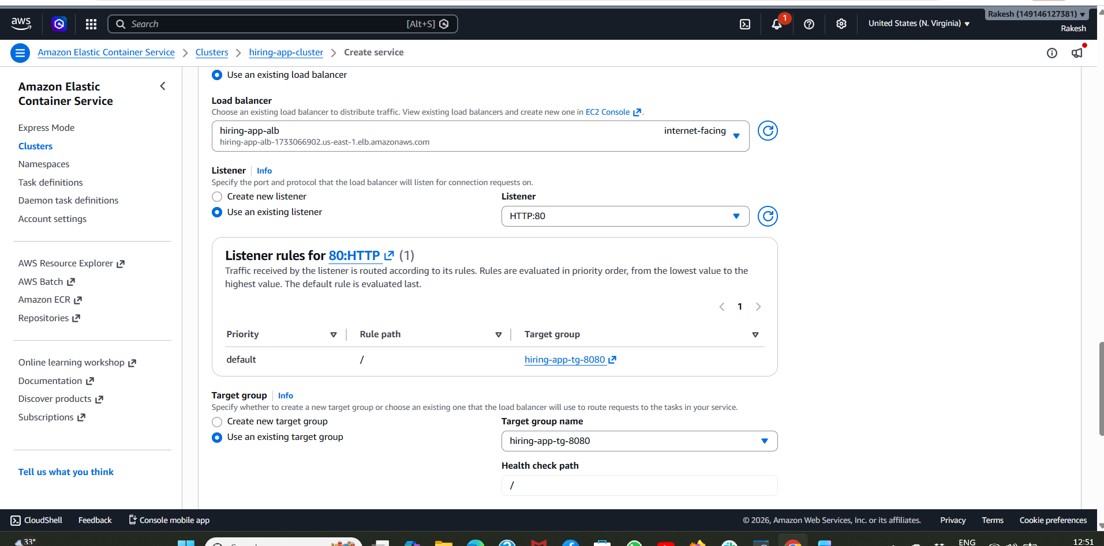
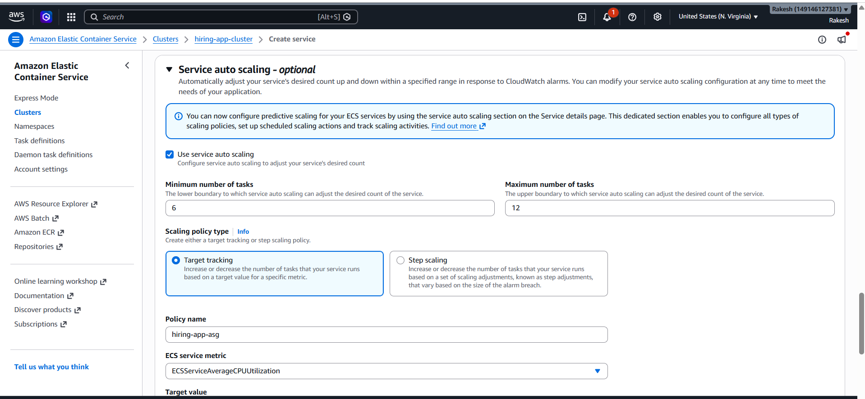
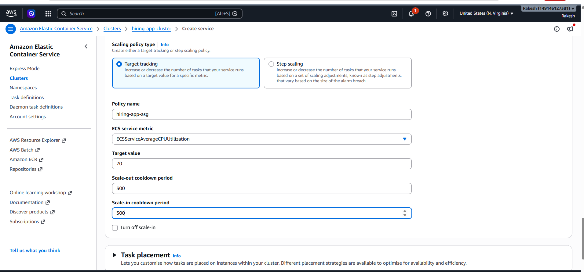
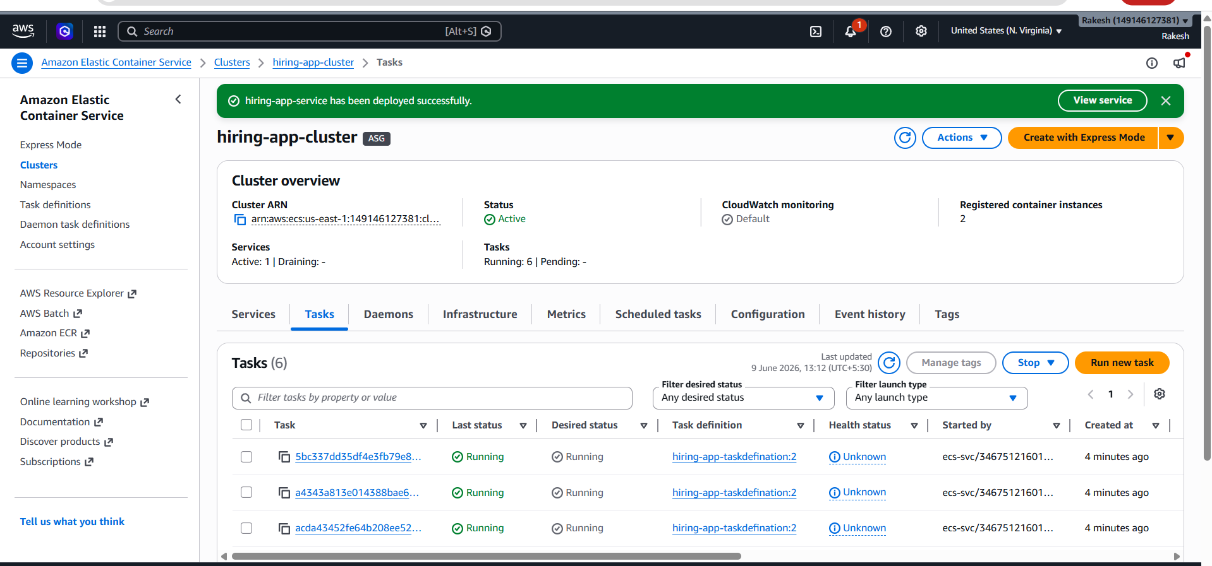

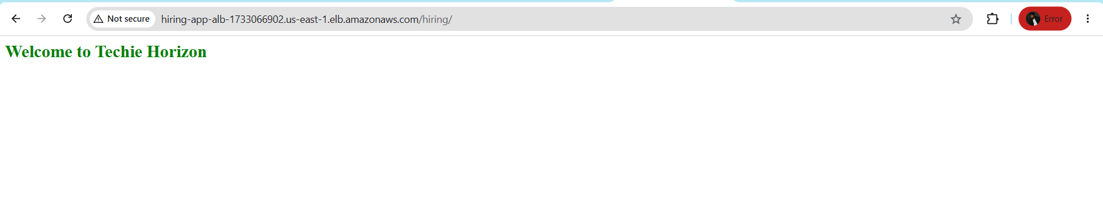
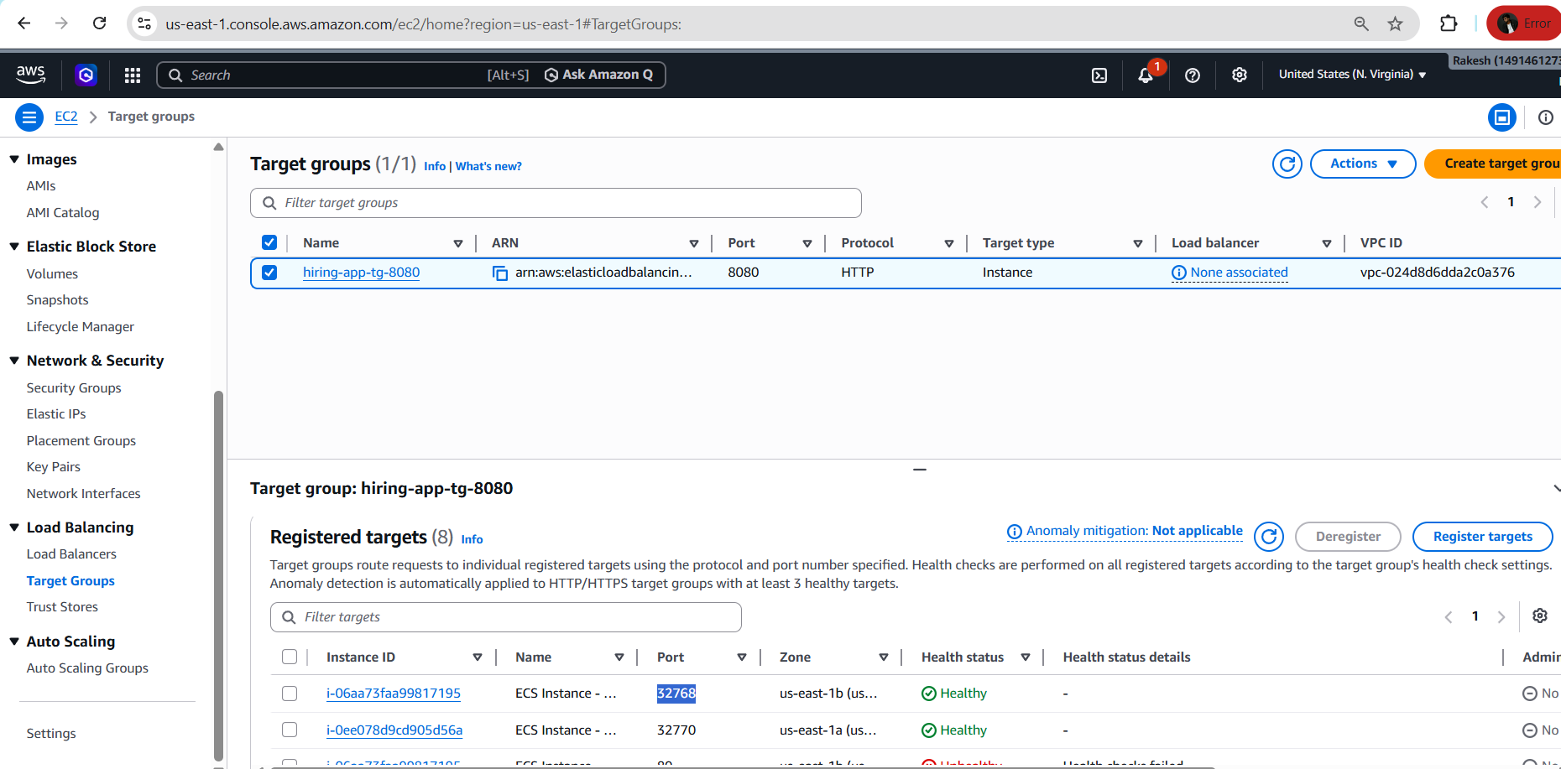

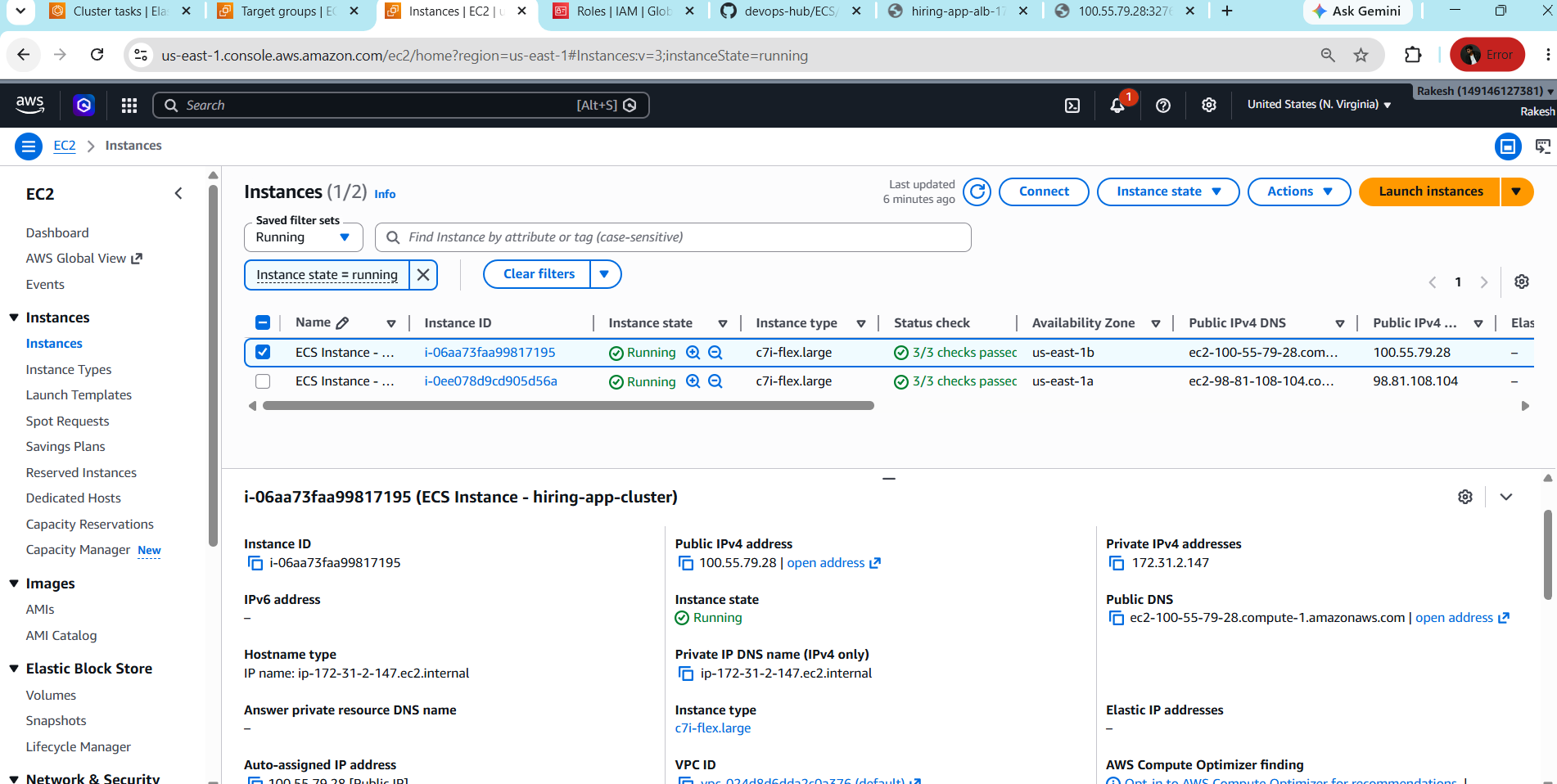

Here we can also check by giving public ip and port num
